SQL – JOINS

1)INNER JOIN – is join used get rows by combining rows of multiple tables with a common attribute

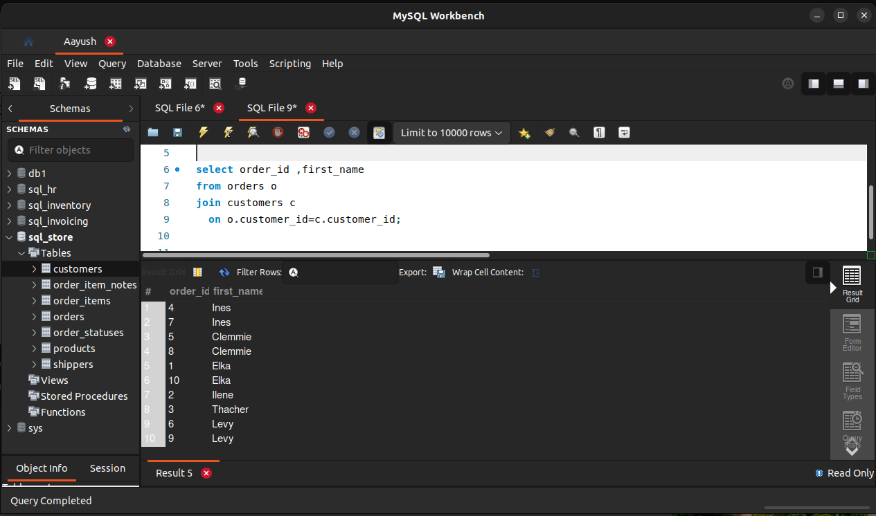

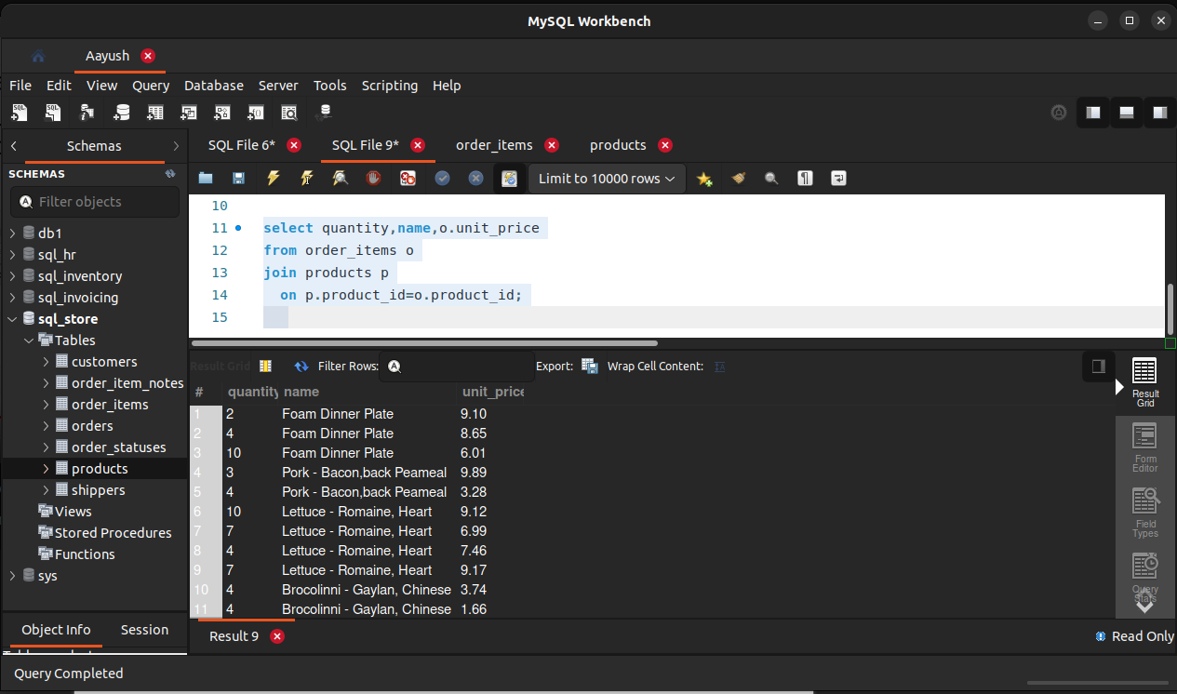

2) SELF JOIN – used join a table with itself
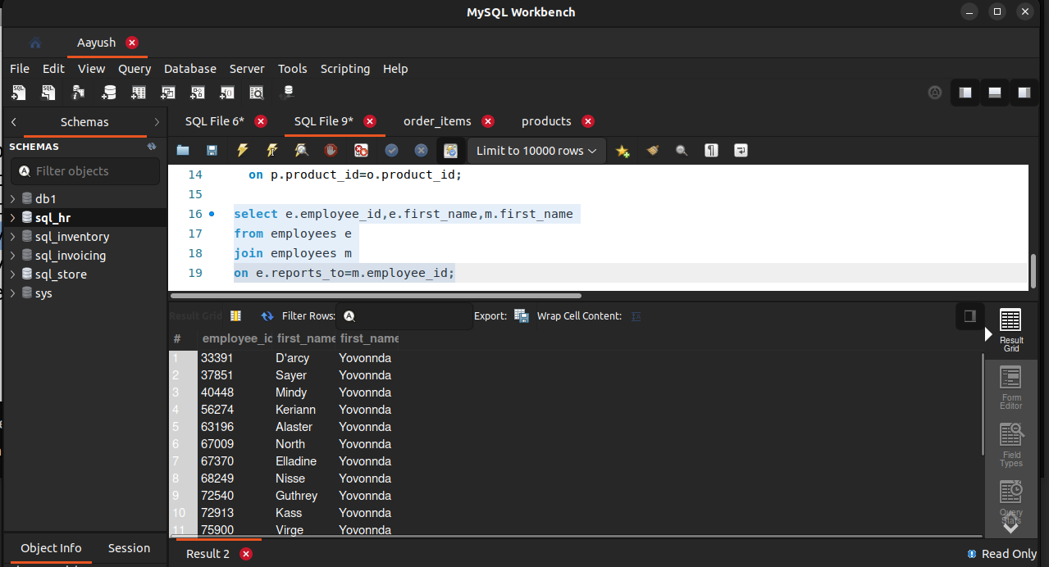
3)Joining multiple tables

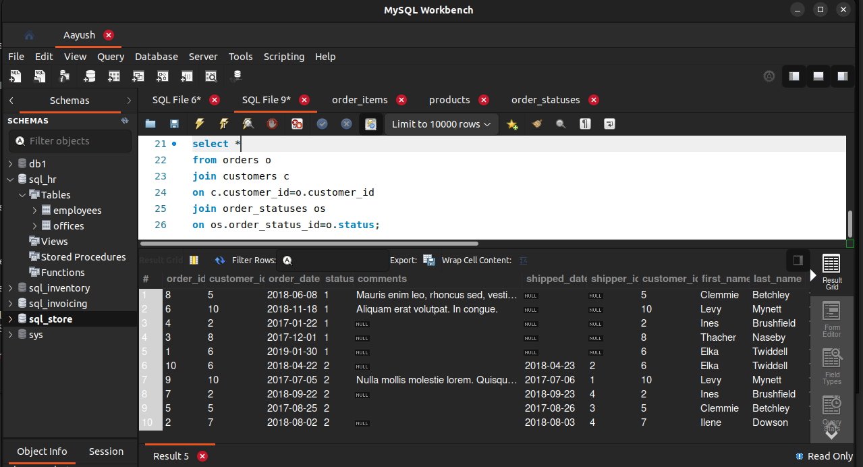

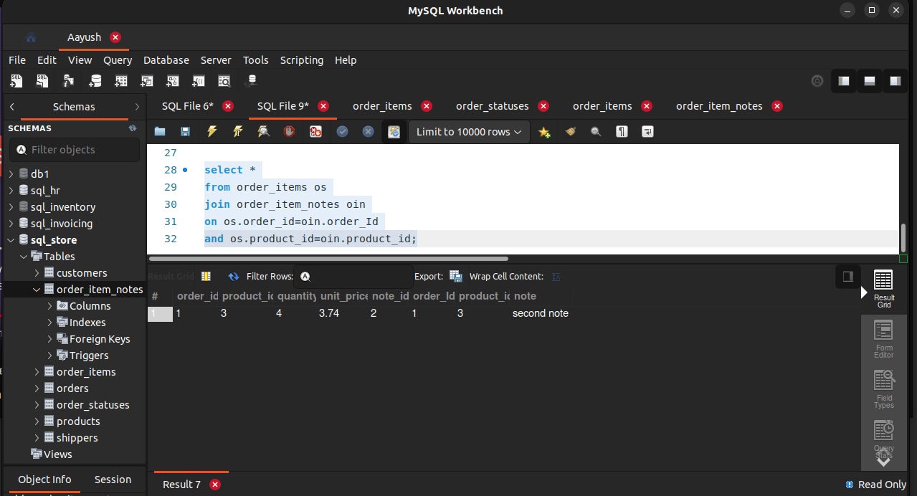
4) Joining using multiple attributes

5)OUTER JOIN – (right,left) gives records in which attributes do not match depending on the right or left join

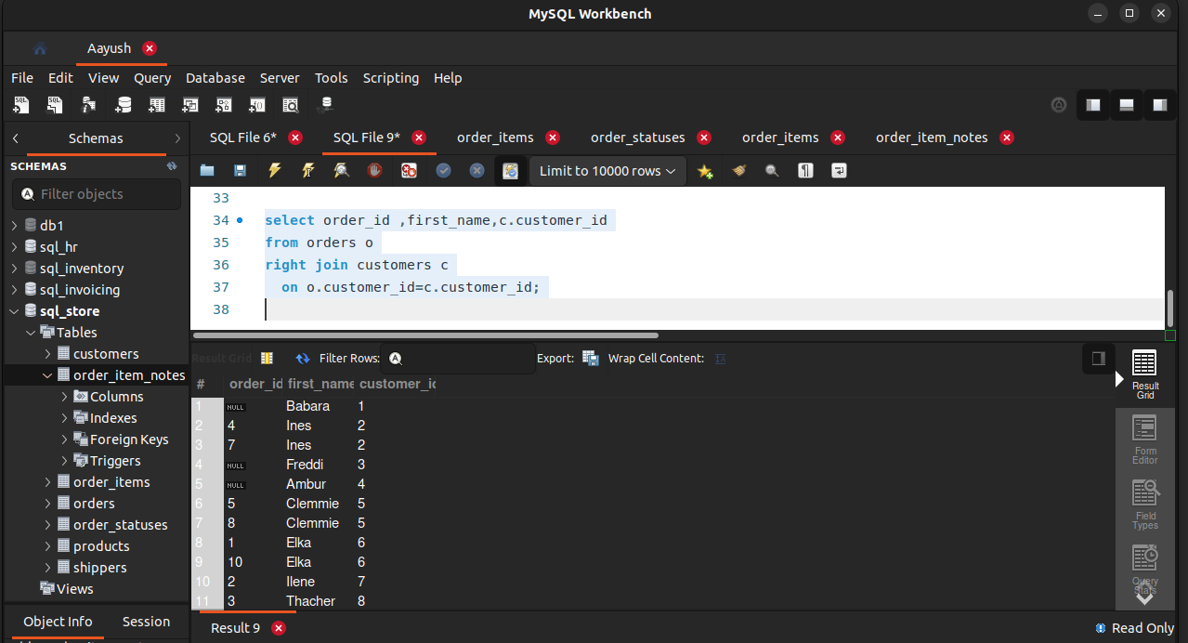

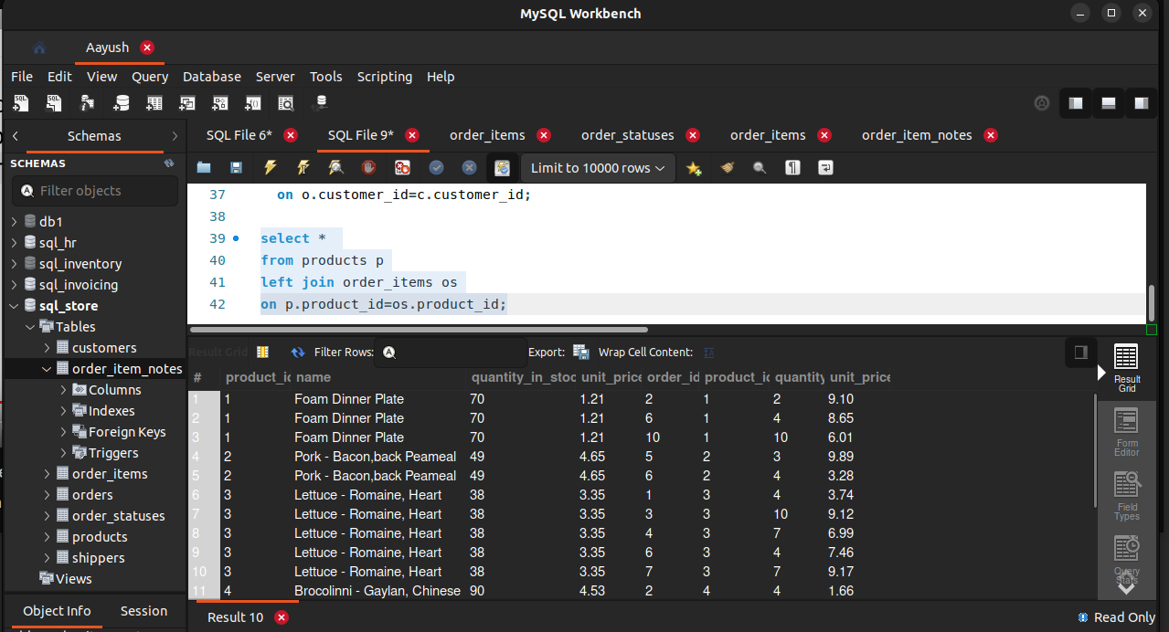
6)self outer join

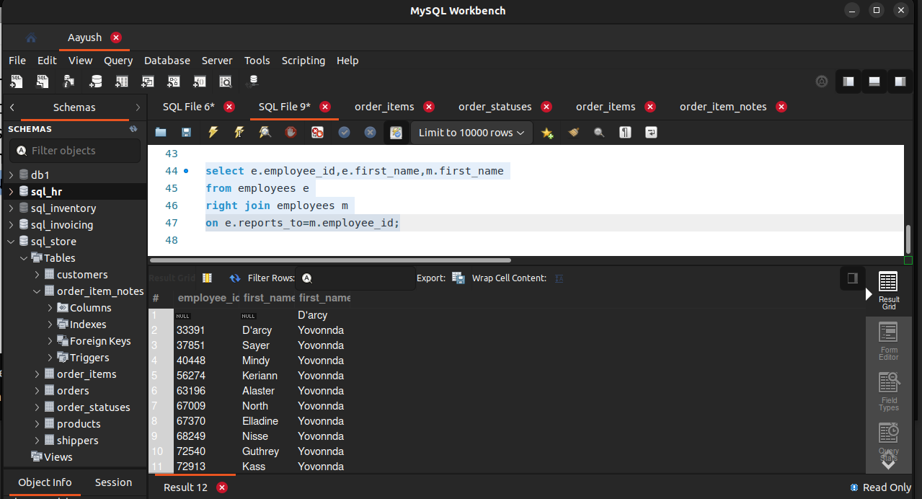

7)NATURAL JOIN – same as inner join but sql figures out which attributes to match itself

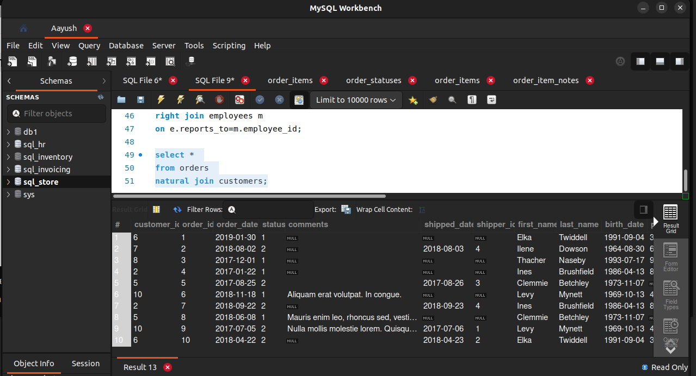

8) CROSS JOIN – performs cartesian product
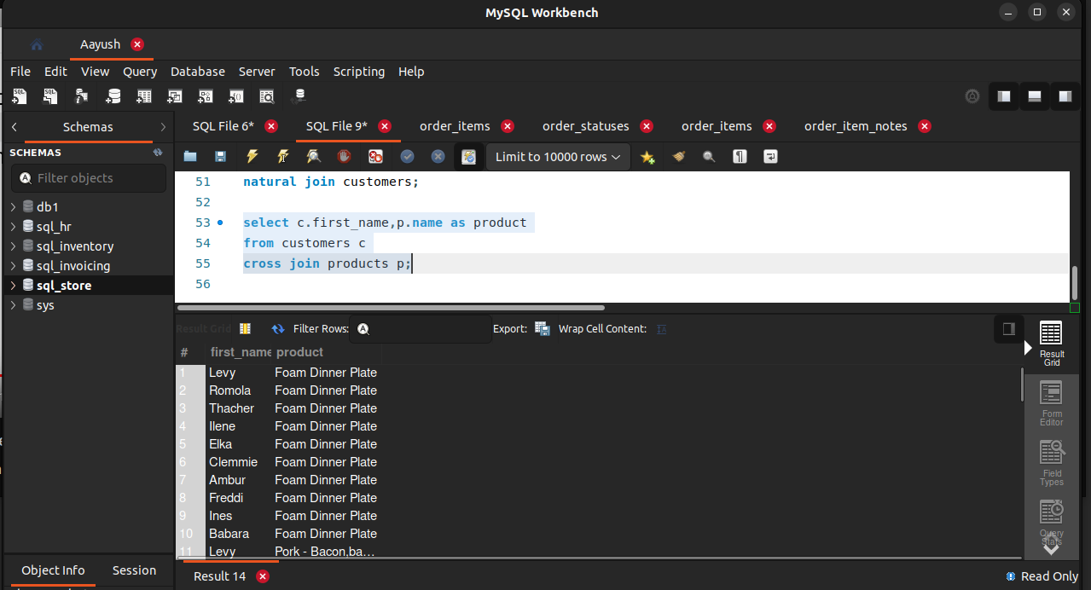

9) UNION – used to perform union

